./

Report – quiz

Course Code: <CODE>



Version Number:

Team Members :

Team No:

Module: Model Based System Engineering

**ACKNOWLEDGEMENT**

**I take this opportunity to express my deep gratitude and most sincere thanks to my project mentor, Mr Bharath for giving most valuable suggestion, helpful guidance and encouragement in the execution of this project work.**

**I would like to thank my mentor for guiding me.**

Contents Page no.

1. Introduction

1.1 feature…………………………………………………………………………………………………………. 5

1.2 Swot Analysis…………………………………………………………………………………………….……… 6

1.3

4whats1how………………………………………………………………………………………………7

2 Requirements

Use casediagram……………………………………………………………………………… 8

Activity Diagram……………………………………………………………………………………………………… .9

**Introduction:**

**quiz is a simple application using c programming language.The quiz is based on c language .Any user can take quiz by entering the name of the user.After entering the details like name,the user allowed to take the quiz.The quiz contains total 10 questions .User has to complete all the 10 questions in order to pass the quiz.It is complied in Visual Studio code using GCC compiler.**

**Features**

**The Key features of quiz are:**

**1.Participate in quiz**

**2.View the result**

**3.Exit**

**Language & IDE**

**1.C**

**2.Visual studio Code**

# 

**SWOT Analysis:**

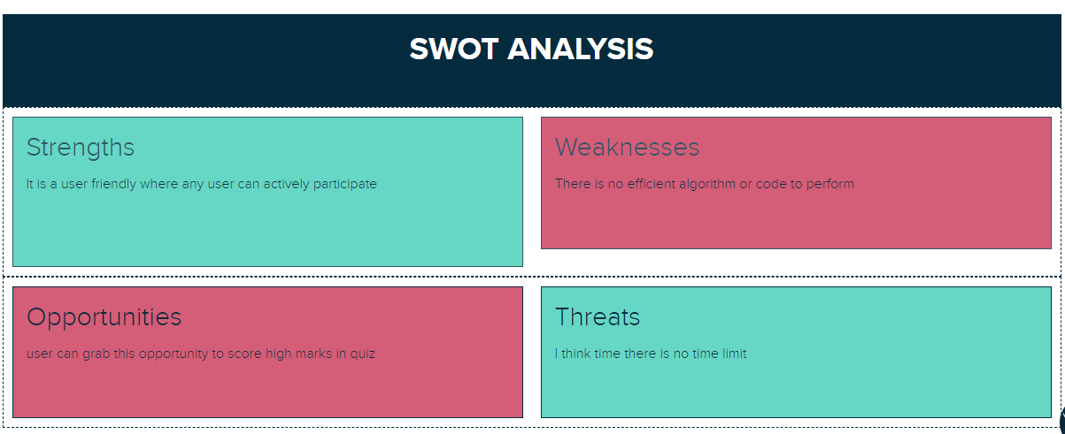

**4W's and 1H**

**Who**

**Any user who are intersted can take the quiz and enjoy the quiz.**

**What**

**The project is main aim is to anyone participate in the quiz.**

**When**

**Students are actively participate because the quiz is based on c language.**

**Why**

**The project is mainly about students to get more knowledge on c.**

**How**

**The user can take the quiz by entering his name**

**Requirements:**

**Use case diagram**

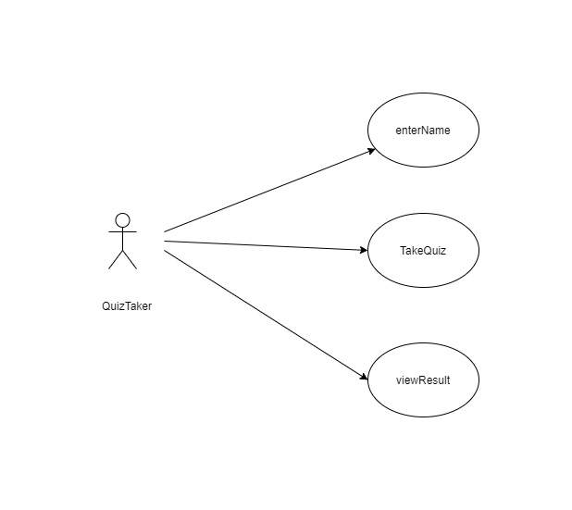

**Activity diagram:**

